**Project Report: Airline Reservation System (MySQL)**

**Project Title:**  Airline Reservation System

**Objective:** To design and implement a MySQL-based backend system to manage flights, customers, seat availability, bookings, and cancellations within an airline reservation framework.

**Tools and Technologies:**

* MySQL Workbench
* SQL (DDL, DML)
* Views and Triggers
* ER Diagram

**Database Schema Design:**

* Flights:
  + flight_id (PK)
  + flight_number
  + origin
  + destination
  + departure_time
  + arrival_time
* Customers:
  + customer_id (PK)
  + name
  + email
  + phone
* Bookings:
  + booking_id (PK)
  + flight_id (FK → Flights)
  + customer_id (FK → Customers)
  + seat_number
  + booking_date
  + status (booked/cancelled)
* Seats:
  + seat_id (PK)
  + flight_id (FK → Flights)
  + seat_number
  + is_available

**Data Normalization:**

* Ensured 3NF (Third Normal Form)
* Removed redundancy and ensured dependency preservation

**Sample Data:**

* 3 Flights with IDs 1, 2, 3
* 10 Customers with name, contact details
* 10+ Seat entries per flight (1A, 1B...)
* Multiple Bookings showing use of constraints and joins

**Views & Triggers:**

* Views:
  + available_seats_view: List of all unbooked seats per flight
  + flight_booking_summary: Shows booking count per flight
* Triggers:
  + On booking insert → set seat is_available to false
  + On booking cancellation → set seat is_available to true

**Sample Queries:**

* Find flights from Origin to Destination
* Check available seats for a specific flight
* Generate daily flight booking summary

**ER Diagram: Included in the appendix**

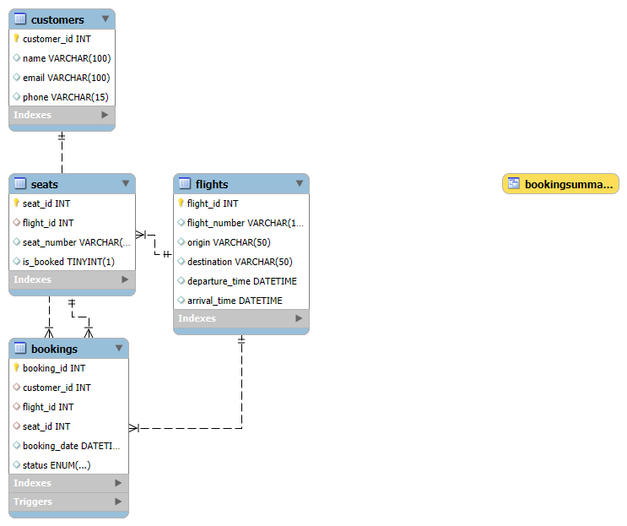

**Output Screenshots:**

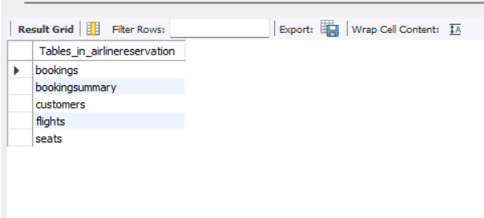Show Tables

DESCRIBE Flights;

DESCRIBE Customers;

DESCRIBE Seats;

DESCRIBE Bookings;

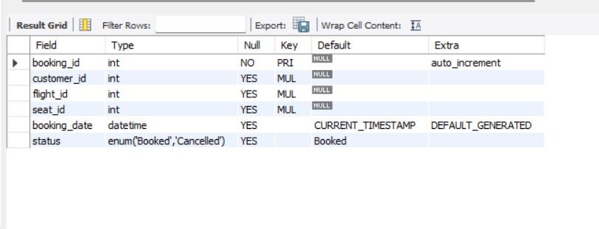

SELECT * FROM Flights;

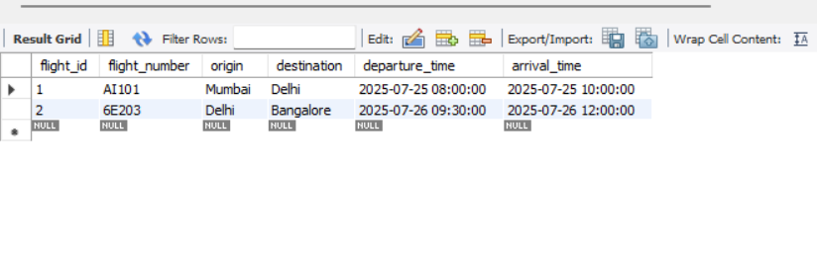

SELECT * FROM Customers;

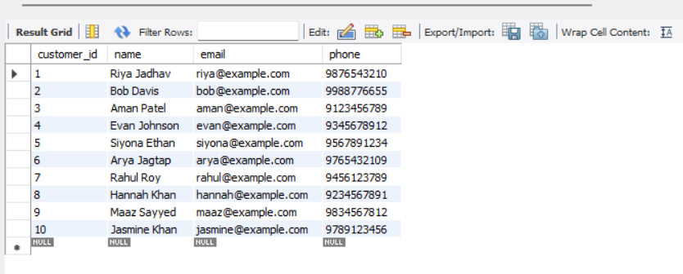

SELECT seat_number FROM Seats

WHERE flight_id = 1 AND is_booked = FALSE;

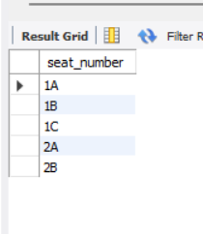

SELECT * FROM Flights

WHERE origin = 'Mumbai' AND destination = 'Delhi';

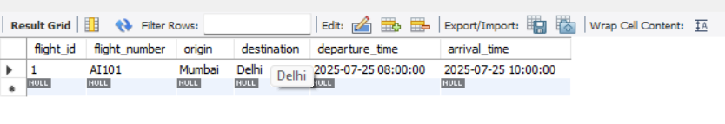

SELECT * FROM Seats WHERE seat_id = 1;

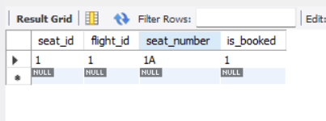

UPDATE Bookings SET status = 'Cancelled' WHERE booking_id = 1;

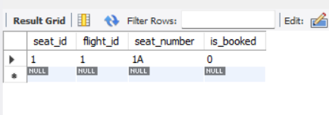

SELECT * FROM BookingSummary;

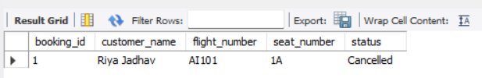

**Conclusion:** This project delivers a practical Airline Reservation backend using MySQL, incorporating key concepts like schema design, normalization, triggers, and real-time seat availability tracking.